**Clock Chain**

Yuling Hou

# 1 Code Structure

The codes has following directory structure

project3

├── Blockchain.cpp # implementation of persistent, mining thread, timer thread

├── Blockchain.h

├── Block.cpp

├── Block.h

├── build/ # folder for building running programs

├── CMakeLists.txt

├── json/ #head files from https://github.com/open-source-parsers/jsoncpp

├── LICENSE

├── Mingclent.cpp #implementation of the client for sending mining request

├── Queryclient.cpp #implementation of the client for displaying the block chain data

├── README.md

├── ChainServer.cpp #clock chain server implementation

├── sha256.cpp

├── sha256.h

├── SHA256-LICENSE.txt

All the programs are in build directory. To build the program from scratch, in the build directory, run following commands in linux:

*cmake -DCMAKE_BUILD_TYPE=Release ..*

*make*

clockchain: the clock chain server

miningclient: the block chain client that communicates with server mining task

queryclient：the client to query the block chain data from the clock chain server

All the codes are available in sunlab /home/yuha20/project3 as well.

# Design

## 2.1 Clock Chain Server

We extend the codes based on the original tutorial block chain in <https://davenash.com/2017/10/build-a-blockchain-with-c/>. In the block chain server, it will create a BlockChain object and then it listens the connection from the client. When there is a request from the client, it will process the request according to the protocol in JSON into a mining request, and put into the queue of minging request.

While in the clock chain server, two threads will be created as the BlockChain is constructed. One thread is the timer thread. It emits a timer mining request every minute into the mining request queue where the mining request from the client is stored as well. The another thread is the mining thread. It reads a request from the queue of mining requests, and does the actual mining work in AddBlock method of BlockChain object.

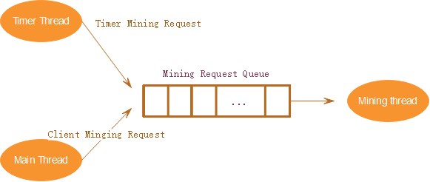

Figure 1 Data flow in clock chain server

When there are multiple mining requests in the queue, it will accumulate the requests in one minging task as far as the accumulated content length is less than 1000 bytes to maximize the revenue from mining.

The block chain data can be persisted into a JSON file named ../json/blockchain.json and recovered from the file. When a new block is mined, it will trigger the save method. When the server is started, it will load the block chain data from in the persistent file. The validity of the persistent file is done in the method of IsValidate in BlockChain object. Any modification of the file will be found since both the hash of the block content and the equality of chain of hashes are checked in this method.

The jsoncpp (https://github.com/open-source-parsers/jsoncpp) is used in this project.

The protocol between the client and clock chain server is JSON format. The flowing is an example.

{

"clientid" : 1,

"content" : "\u0007\r\n\u0001E\u001d\u0000E\u0002R\u0011\u0011\u0000\u0011",

"op" : "mining",

"time" : 1607095340,

"token" : "xxxxxxxxxxxxxxxxxxxxxxx"

}

“clientid”: the unique identification for client

"content":the content to be mined from client. It was encrypted in client and can be decrypted in client for security and privacy reason.

"op" : the operation mode for the request. "mining" marks a mining request. “inquiry” marks a block chain query request.

“time”: the time stamp from client.

“token”: the token used for authorization in server.

## 2.2 Mining Client

The mining client send the mining request to the clock chain server in the protocol defined above.

It uses XOR to encode the content in the mining request.

## 2.3 Query Client

It sends the query request to server to get the data of block chain and show the response

# Test Scenarios and Results

|  |  |  |
| --- | --- | --- |
| **Test Area** | **Test method** | **Test Result** |
| Time Block | Run the server, and see if there is a new time block generated every minute | Time bock is generated and processed correctly |
| Ming Request | The client sends the mining request, and check whether the server can receive the request and process correctly | Ming request is received and processed correctly |
| Persistent/save | when a new block is generated, check whether it is added the persistent file | new block is added to the file ../json/blockchain.json |
| Persistent/load | kill the server, and restart the server, and to see if all the blocks are loaded correctly. | all the blocks in chain are loaded correctly |
| Validity | change the content of a block but not change the hash in persistent file, restart the server. | the server find that the content is changed and report an error |
| Validity | change the content and calculate the correct hash for the content | the server find that the content is changed by checking the chain of hashes and report an error |
| Display the block chains | use query client send the query request to the server, the server will response with a JSON string of block chains | block chains is displayed in the client |
| Performance | sends 10 requests in 1 minute to simulate requests from many clients simultaneously | the server can receive all the requests and put it into request queue. |
| Performance | make the timer interval short to generate more time block request to see if the server can process correctly | The requests in the queue can be combined together as far as the accumulated content length is shorter than 1000 bytes |

# 4.Mining Performance Analysis

According to the project requirement, only one miner is in the server. The miner read a mining request from front of the mining request queue. if the content in the request is less than 1000 byte, and there are more requests in the queue, it will read another request and combine the requests into accumulated request until the queue is empty or the number of bytes in accumulated request reaches 1000 bytes. The original request in accumulated request s separated with “$”, so that it can be read correctly in the clock chains.

The speed of mining a block depends on the _nDifficulty level in Blockchain object. In the MineBlock method, it calculates the hash of a block , and checks whether all the chars in the number of nDifficulty in the left of hashes are zeros. It not, it will change the _nNonce, and calculates the hash again until a correct hash is found. So the value in _nNonce marks how many time of calculations before the correct hash is found, we can call it “effort”. This _nNonce is variable so the cost time of mining a block is variable as well.

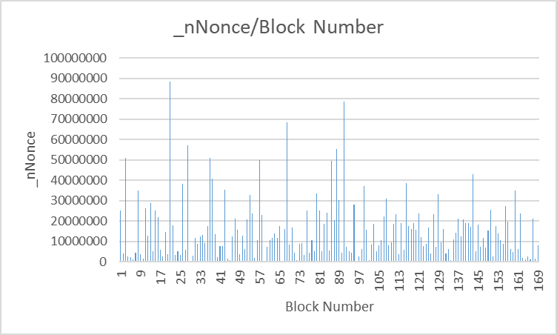

Figure2 the number of _nNonce for every block

But if the more power of CPU/GPU, the less time it costs for calculating of the hash of a block, hence the average of time costed for mining a block is less. So a computer with a powerful CPU/GPU can mine more blocks than or normal computer in a fixed time.

The smaller of _nDifficulty, the more speed of mining. But a smaller _nDifficulty can make the forge more easier as well. So we can not just set a smaller nDifficulty to speed up the mining process.

Another improvement of mining speed is that we can use multiple miners, but need to some collaborations since we should keep _nIndex strictly increase in each block of the block chains. Supposed that average of _nNonce for all the block in the chains is ExpectNonce, if we have 2 miners, than we can let miner one start from 0 for _nNonce in MineBlock method, and another miner to start from ExpectNonce in MineBlock method. Any one of the two miners finds the correct hash for the new block, then the new block will be mined successfully and added to the clock chains.